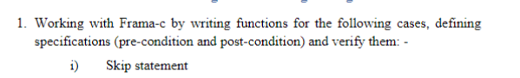

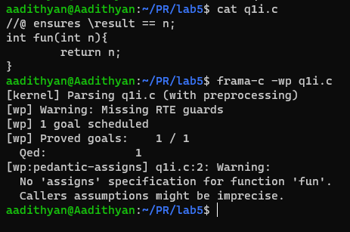



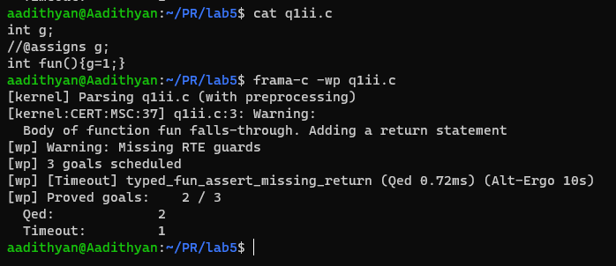



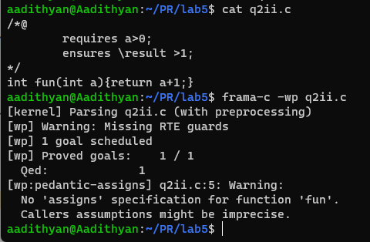



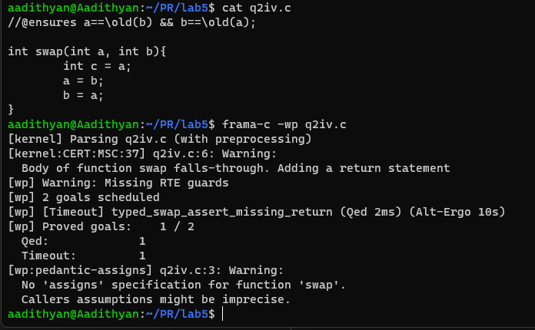



P = wp(s,q)

P = wp (x=5, y>x)

P = y>5

P = WP ( S1 , WP ( S2 , Q ) )

P = WP ( S1 , WP ( y = x + 5 , y > 5 ) )

P = WP ( S1 , x + 5 > 5 )

P = WP ( x = z + 1 , x > 0 )

P = z + 1 > 0;

P = z > -1

P = (y<0)^wp(x=y+1,x>0) V (y>=0)^wp(skip, x>0)

P = (y<0)^(y>-1) V (y>=0)^(x>0)

P = F V T

P = (y>=0) && (x>0)

P = (y<0)^wp(x=y+1,x<0) V (y>=0)^wp(x=y-1, x<0)

P = (y<0)^(y<-1) V (y>=0)^(y<1)

P = y<-1 OR y=0

